# Lab One: Virtualization on RLES

Write up due 2/13 in the dropbox.

URL to access RLES: <https://rlesvcloud.rit.edu/cloud/org/nat/>

You will log in with your regular RIT credentials.

## Introduction/ Use Case:

In this lab we are going to begin to build a very useful architecture that will serve as the basis for most of the labs for the rest of the course. You might recall doing this lab in NSSA 605 except there we used VMWare Workstation either on your laptop or in the lab. This time we are going to use a private cloud that the IST department owns called the Remote Laboratory Emulation System (RLES). It is a very cool architecture that will give you a chance to try a significantly different architecture. We will use RLES for several more labs this semester and each lab will be an extension of the work that we will do in this lab.

To do the labs we want to do what we need is a place to deploy services where we will not be bothered by any of the network or system services that are deployed to make the RIT Lab work such as DHCP for our desktop computers and DNS for the AD membership of the desktop computers.

In this lab we will work with RLES to create a private network with four virtual machines (operating systems) that we will use throughout most of the rest of the semester. To accomplish the labs we are going to need access to a router, two servers and a client. For this lab we will use a Vyatta router, an MS Windows server 2012, a CentOS server, and a client.

We will use a virtual router as part of our configuration because if we tried to build a private environment in RLES is that it wouldn’t be private at all, it would be exposed to the entire RLES because there would be no barriers between our systems and the rest of the lab.

There are lots of ways that we could address this issue, but the way we are going to fix this is through the installation and configuration of a router. This doesn’t mean that you all have to line up at the cage and ask for a pretty green box, we are going to install a virtual machine that acts as a router, a virtual router. A router is nothing more than a computer with at least two network interfaces configured to use a routing algorithm to decide if a packet that arrives on one interface should be dropped because the source and destination IP addresses are on the same subnet, or should be forwarded out the other interface because the source and destination are on different subnets.

To set this up we would normally have to do a few things, install our virtual router as a vm in RLES, attach to a private LAN segment, configure the router so that it has two network interfaces with one connected to our new LAN segment, then power up the new vm and configure it with the information it needs to make the decisions we want it to do. Then we have to test our configuration to see if it behaves as we expect it to do. Since we are going to do this every time we restart this configuration you might want to put your test into a script so you can just run the script, and not have to type in all the commands. Last, but certainly not least, we have to back-up our router configuration file so that if the router decides to lose its configuration we can get it back with a minimum of typing.

To make this work we will connect one interface of our router to a private LAN segment and the other to a public LAN segment so we will have an isolated environment in which we can deploy services and not have to worry about our services leaking out into the rest of the RLES.

Because I am a nice guy I have set up a lot of this work for you in the form of a vApp named vApp_cbbics_2145. The network diagram for this vApp is below. The first thing that you need to do before you turn on these virtual machines is to create your own copy of the vApp by following the steps below:

Your vApp template is now in the catalog.  Here are the steps your students would use to deploy their own copy of the vApp from the template:  
  
1. Click the green '+' to Add vApp from Catalog.  
2. Click All Templates.  
3. Select cbbics_vApp2145 and click Next.  
4. Give the vApp a name (include your username in the name) and click Finish.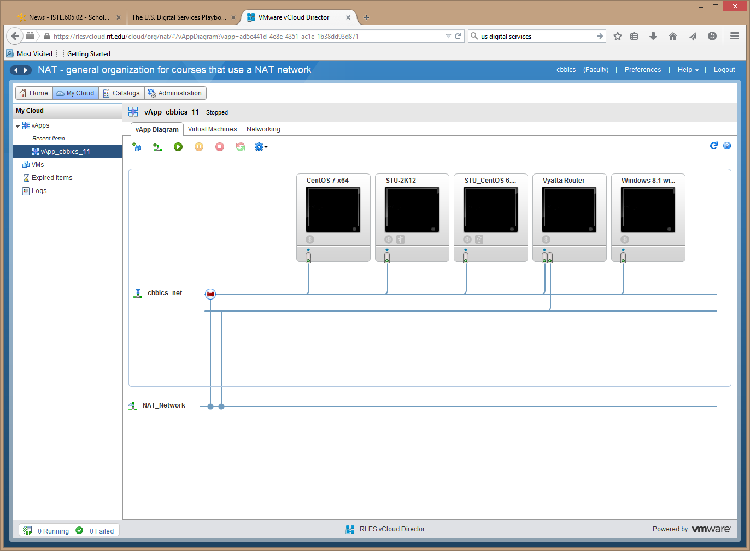

Our goal for this lab is to just to get this up and running and to test it to make sure that it performs the way that we expect it to.

## Lab Outcomes:

The main outcome for this lab is for you to feel comfortable working with RLES as an environment the vApp that you have created. You should be able to start and stop VMs, move between their consoles, and configure settings such as shared drives, allocation of virtual CPUs, and RAM.

Outcome One:

Develop a Visio drawing that displays the architecture of the lab after you have completed your work. This should be done **before** lab so you know what you are doing. Include in your drawings things like host names, IP addresses for those machines that will receive their addresses statically and services provided by the machines. I have included an example below, but it is not a correct version of what you will have after this lab. It is just to look at.

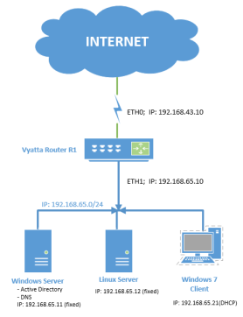

Prior to lab you are to develop a Visio drawing of what you are building complete with the servers and clients that you plan to deploy and the relevant information needed to accurately deploy them (computer name, IP Address, services to be deployed, relationship to other machines, etc.). The drawing above is illustrative of what I want, but it obviously does not have the correct information on it. It is resizable, just drag on a corner.

### Deliverables:

Visio drawing is complete with devices displayed and network illustrated. IP addresses are shown and services deployed shown.

|  |  |  |  |
| --- | --- | --- | --- |
| How difficult do you feel this part of the lab will be for your group? | Way hard | Not so hard | Easy |
| What resources do you plan to use to help you complete this part of the lab? | |  | |
| **Outcome one completed:** Visio drawing completed of acceptable quality. | | **Your signature:** | |

## Outcome Two:

The main outcome for this part of the lab is for you to configure your Vyatta router, an AD DC, and any other network services that are needed to create a truly useful environment. It is up to you to decide what services need to be deployed and where to deploy them. You have lots of options.

**Deliverables:**

The Vyatta router is configured and all network services are installed and operational.

|  |  |  |  |
| --- | --- | --- | --- |
| How difficult do you feel this part of the lab will be for your group? | Way hard | Not so hard | Easy |
| What resources do you plan to use to help you complete this part of the lab? | |  | |
| **Outcome Two completed:** | | **Your signature:** | |

**Outcome Three:**

Your next outcome is to configure the Vyatta router to provide routing services to create a private network to use to deploy services from our other virtual machines. For now you can configure the Vyatta router to provide DNS and DHCP services and any services that you think appropriate. We will change this in later labs. As part of this lab you are going to have to think about the types of services that you will need to provide to make your internal network fully functional. Also, since we have to test everything that we do to make sure that it performs as we expect, you need to think about how you test your configuration. Because you would normally do this through a series of command line tests, combine these tests into a script that you can run at the beginning of each lab to make sure that all is working as expected. Finally, since we don’t trust any system to maintain its configuration, back-up the Vyatta configuration into both a separate file stored on the Vyatta router and another file stored someplace that is isolated from any failures that might occur that would require you to reinstall your Vyatta image (like a USB stick or file share).

**Deliverables:**

Vyatta router is fully configured and functional. A script has been written that tests the basic functionality of the router, the router configuration has been backed-up to at least two places, one internal to the Vyatta and the other external, and the other VMs have been fully integrated into the new network.

|  |  |  |  |
| --- | --- | --- | --- |
| How difficult do you feel this part of the lab will be for your group? | Way hard | Not so hard | Easy |
| What resources do you plan to use to help you complete this part of the lab? | |  | |
| **Outcome Three completed:** | | **Your signature:** | |

## Results:

Please answer the following questions in a short (one or two paragraph) answer:

1. Do you think you are ready to do the labs that we discussed in class on this architecture?
2. Now that we have created back-up versions of our router configuration is there anything else we need to think about to ensure the availability of the Vyatta?

**How Would You Do This Differently Next Time?**

Please take a few minutes and tell me how this went for you. How could we do this better next time?